Mostafa Vahidi

CS 4310.01 Operating Systems

Prof. Diaz

9/24/18

Program 1 Nachos Installation + Exercise

1. Using the config file given above, what is the number of physical pages in the main memory?

Since physical pages get allocated through the processor but in project 1 config file, the processor field is set to false, I’m assuming that the number of physical pages allocated is 0. You can see a screenshot of the file below that supports my answer. Otherwise, the default number of physical pages allocated is 64.

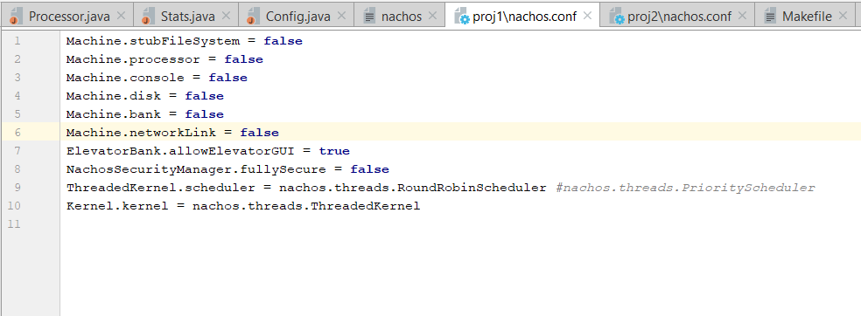

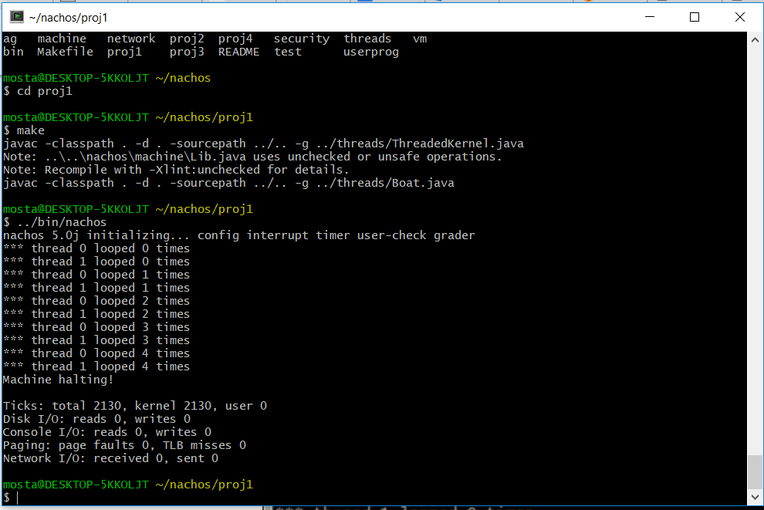

You can also see that the nachos is installed in my local desktop (mosta path [short for Mostafa) as proof that I have Nachos cygwin and Nachos environment set up.

2) Why is not any processor object created in this example? How can Nachos simulate a machine without any processor?

There is not processor object created because the program is using the computer's processor. Nachos can simulate a machine without a processor by creating threads that use my own laptops processor side by side with Linux and Windows OS.

3) Provide a snapshot of the outputs from Nachos running the config file in project 1. Compare the results when running it multiple times. Are they all the same? Why?

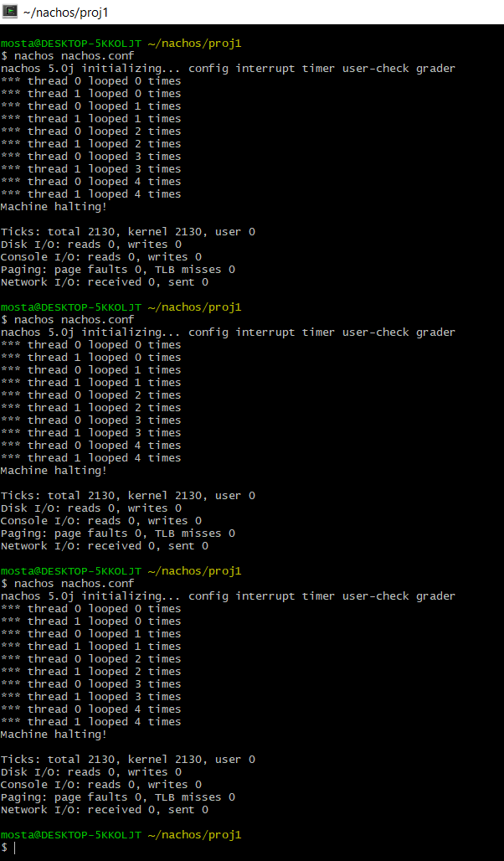

Yes, even after running it multiple times, the results of running nachos.conf in proj1 directory is still the same as seen in the previous screenshot. I believe this is because there are no processes being allocated through the Machine class and config class in project 1. The stubFileSystem, processor, console, disk, bank, and networkLink are all set to false which wouldn’t change the output of the config file even after multiple runs.